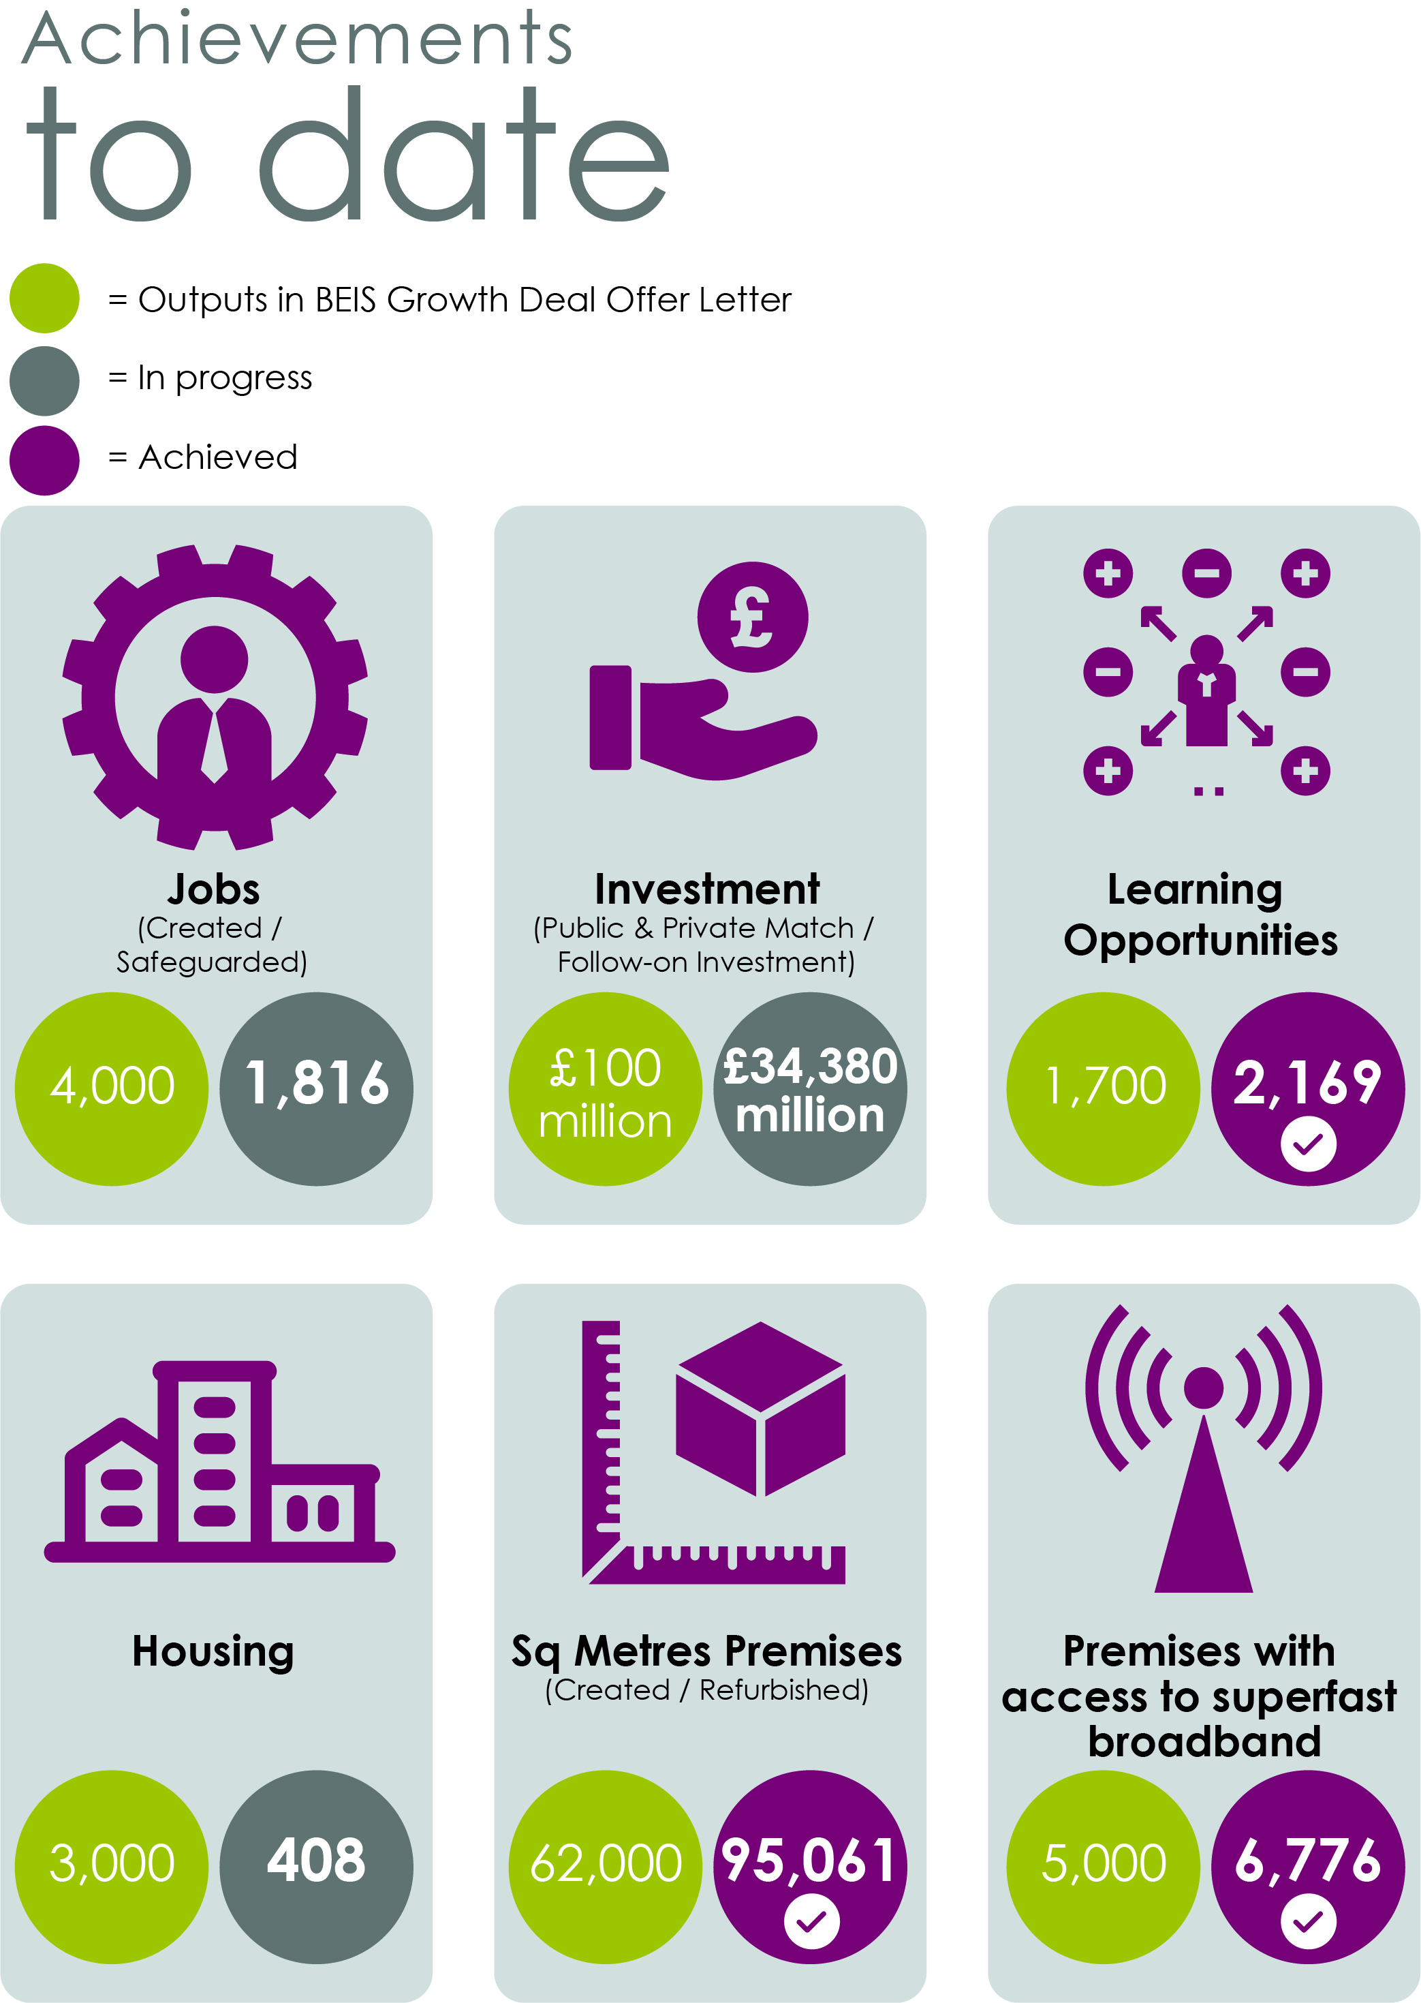
Programme Performance – At a Glance

Contents

1. Introduction 4

2. Strategy 4

3. Governance 7

4. Establishing CLEP as a Company 10

5. Delivery - Key Indicators for the 2019/20 Delivery Plan 11

6. Local Growth Fund Activity 11

7. Other Funding or Growth Programmes 15

8. Multi-LEP and Working Outside Cumbria 23

Annex 1: Final Draft Local Industrial Strategy

Annex 2: Summary of Action Points

Annex 3: Glossary of Terms

Appendix A: Governance Improvement Plan

Introduction

The Annual Delivery Plan is a new requirement of all Local Enterprise Partnerships in response to the “Strengthened Local Enterprise Partnerships” report produced by government in July 2018. The 2019/20 Annual Delivery Plan is a ‘light-touch’ version of documents that will be produced in future years, recognising that 2019/20 is a transitional year as LEPs collectively work with government to fully develop the expectations of the Annual Delivery Plan.

Cumbria LEP (CLEP) has structured its delivery plan around the three themes of the Annual Performance Review – Strategy, Governance and Delivery – with the focus of this report being primarily on the delivery aspects of all funded programmes and activity.

Strategy

Cumbria’s Strategic Economic Plan (SEP) was due to receive a fundamental review in 2018/19 and rather than complete this, the Board decided and agreed with government that CLEP should move with pace to the development of its Local Industrial Strategy.

CLEP therefore embarked on the development of its Local Industrial Strategy (LIS) in 2018, via a seven stage consultation process that ensured that all partners were fully engaged in the development of the strategy, as outlined below:

Stage 1 April 2018 – refreshing the focus of the partnership Steering Group

Stage 2 April 2018 ongoing – partnership awareness programme via presentations to a wide range of organisations and events

Stage 3 July 2018 – securing partnership buy-in to the emerging evidence base and the headline issues through 4 partnership workshops

Stage 4 October/November – partnership consultation events on the draft outline LIS

Stage 5 – November – 14 December online consultation on the draft outline LIS

Stage 6 – mid/late February 2019 – partnership consultation events on full draft LIS

Stage 7 – 11-23 March 2019 – online consultation on the final draft.

The LIS has sought to respond to seven strategic imperatives (declining working age population; thin higher level skills; pockets of worklessness and deprivation; fewer business start-ups; less fast growing firms; patchy innovation; and infrastructure and connectivity related to a large predominantly rural geography), which need to be addressed in order to maximise Cumbria’s growth potential. The document has been structured around the five drivers of productivity, with a further overarching priority related to place marketing and promoting Cumbria as the place to live, work and invest, recognising that the area has the slowest growing population of any LEP area. The key priorities are therefore as follows:

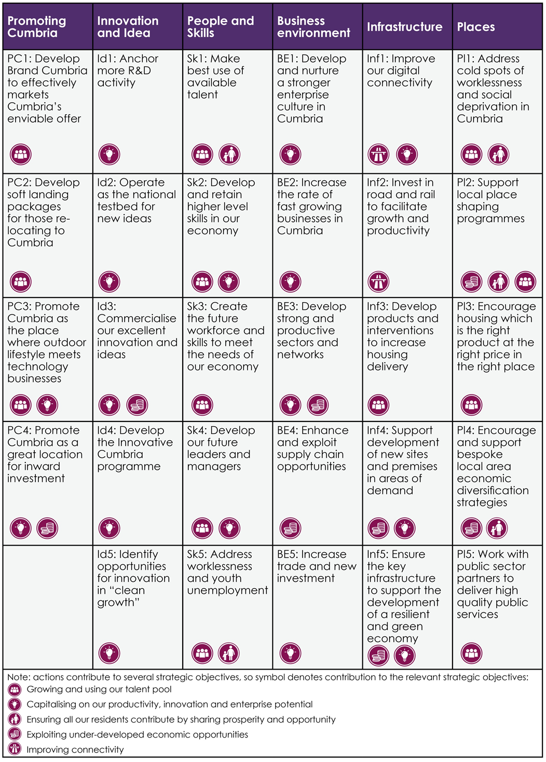

The final draft LIS (Annex 1) was produced in March 2019 and submitted to government, following approval by the CLEP Board on 29 March 2019. Initial conversations took place with government during late March and early April on the content of the LIS, including with analysts on the underpinning evidence base.

CLEP’s strategic priority for 2019/20 is therefore the finalisation of the LIS, through a process of co-production with government. This finalisation will focus on jointly addressing the following issues, which have been identified as priorities through the initial feedback sessions:

Structure and Style – refining the document to meet government’s style guide once this is available and simplifying the flow through from strategic imperatives to delivery priorities;

Evidence Base – sharpening this further in line with the feedback from analysts;

Natural Capital – developing methodology to better quantify the value of this;

Executive Summary – developing this once re-structuring work on the LIS is further advanced.

Initial work on target setting for the LIS has identified two overall targets for the 10- year period of the strategy: to improve overall productivity levels; and to retain and increase the number of working age in the county. The LIS identifies 10 potential targets to measure progress, which will be discussed with central government during the spring and summer of 2019 as part of the co-production of the final LIS.

During the transition period it was agreed that decisions would be framed within the context of the SEP, until the LIS was sufficiently advanced to provide the necessary strategic framework. Decisions in relation to project funding in 2019/20 are therefore still being considered against the SEP but increasingly against the LIS, and where appropriate the European Structural Investment Fund Strategy. Part 2 of CLEP’s Local Assurance Framework provides full details of the systems and processes for project prioritisation and investment decisions.

CLEP’s performance in 2018/19 was assessed as good and the intention in 2019/20 is to build upon this sound platform to move CLEP’s performance level to the next level.

Governance

Improvement Planning

During 2018/19 CLEP undertook significant work to improve governance, accountability and transparency, following an assessment of inadequate following the 2017/18 Annual Performance Review. The incoming Chair and Chief Executive therefore developed a significant programme of work to respond to all of the issues identified through numerous reviews and scrutiny activity including government’s deep dive report, the recommendations from the Mary Ney Review and an independent review of CLEP by S4W, which was commissioned by CLEP’s then Scrutiny Committee.

The full implementation of all findings was completed by the end of September 2018, following the receipt of government’s deep dive report, which was issued to CLEP at the end of June 2018, considered by the Board at its 13 July meeting, with the full response agreed and implemented at the 28 September Board meeting. Government confirmed that all issues had been satisfactorily addressed. A further update was provided to government on the deep dive report in April 2019, as supporting evidence to the Improvement Plan, to demonstrate that the changes made to respond to the recommendations had been fully embedded.

The main changes introduced as from 28 September 2018 were a revised Local Assurance Framework, which was fully compliant with government guidance and responded to the recommendations in all review and scrutiny activity; new induction and training on code of conduct and conflict of interest for Board members developed in partnership with the Accountable Body; governance arrangements structured around the emerging LIS, with five Strategy Groups centred on the drivers of productivity; improvement of the website to increase its visibility and transparency; and the introduction of a public Annual General Meeting on 28 September 2018, which was widely advertised and secured significant stakeholder attendance. This meeting was supported by a significantly enhanced Annual Report, which will be further developed in 2019.

This progress was recognised in the 2018/19 Annual Performance Review which recognised that if assessed as at March 2019 governance would be ‘at least good’ but as government was completing its assessment over the entirety of the year it was categorised as ‘requires improvement’, as until September 2018 work in responding to the Deep dive report had not been finalised. An Improvement Plan was requested and a copy of this is provided at Appendix A. This focused on the agreed action points from the Annual Performance Review given that all other recommendations from the deep dive and other scrutiny activity had been fully addressed. A key priority is therefore to ensure that the actions within the Plan, which has already been completed, are fully embedded during 2019/20.

Board Development

The Board has been through a significant development phase during 2018/19 with its membership extending from 13 members to 19 members during the last sixth months of the year. This recruitment included a targeted recruitment campaign to secure a further three female private sector Board members to ensure that the gender milestone target for 2020 was reached in February 2019, a year early.

Another priority has been to ensure that succession planning arrangements were put in place for replacing the Deputy Chair, for whom government had agreed an exceptional extension beyond six years, to allow a smooth handover period to the new Chair, who started in June 2018. The Deputy Chair stands down at the 17 May 2019 meeting, with her successor taking up appointment at that meeting subject to Board ratification. The ballot was completed on 26 April with the Deputy Chair appointed, subject to the Board’s ratification. A handover process is being put in place between the outgoing and incoming Deputy Chair, with the Chair and Chief Executive providing ongoing support to ensure a smooth transition.

A further targeted Board recruitment will be undertaken to replace the outgoing female Deputy Chair. This will be completed alongside a recruitment for an additional Board member to take up the remaining place to take the Board to its full complement of 20 members.

CLEP will continue to ensure the ongoing development of its Board and continue to refine and develop its induction and training processes and incorporate the emerging programme being developed by the LEP Network.

Once the Board is at full complement a Board development day will take place, focused on collaborative leadership, strategic prioritisation and other Board priorities as identified by members.

Governance Structure

Significant progress has been made in implementing the new governance structure, with the majority of the sub-Board governance bodies now on their second meeting under the new arrangements. The structure is outlined below:

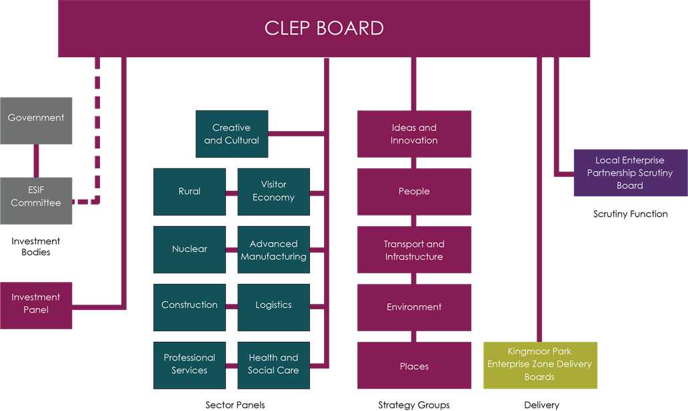

The main governance priority for 2019/20 is to embed the new Local Enterprise Partnership Scrutiny Board. It was agreed that until this was operational the Accountable Body’s Scrutiny Management Board would undertake the role on an interim basis, with it holding a special meeting on 12 March 2019 to complete an annual review of CLEP’s governance, delivery and strategy in line with the national Annual Performance Review Framework. This special meeting, with co-opted members from the district authorities, reviewed CLEP’s performance on these domains, including progress on developing the Local Industrial Strategy. This was alongside CLEP attending seven separate Scrutiny Committees hosted by individual Local Authorities during 2018/19.

The Accountable Body approved the new Local Enterprise scrutiny Board and the proposals for LEP scrutiny at its annual meeting on 11 April and established a new committee with 14 voting County Council members and 6 voting co-opted members from the District Councils. The Committee’s sole remit will be LEP Scrutiny, with the Accountable Body servicing this Board, which will meet twice per year, with the inaugural meeting taking place on 12 September 2019. In advance of this a training session will take place for all elected members involved in the Board. CLEP has made it clear that the Board will be totally managed by the Accountable Body, and the Chair and the Chief Executive will report to it, on behalf of CLEP.

The strong progress made to date means that the focus is on maintaining that momentum and ensuring that all sub-Board bodies are operating to a consistently high standard with a focus on implementing the LIS. The focus during Quarter 1 will be on formalising the operations of the two Sector Panels - Construction and Professional Services – that are still in the developmental phase, to move these to formal meeting cycles. One of the newly-appointed Board members, with specific experience in construction, has been appointed to Chair the Construction Sector Panel.

Further Priorities

Other priority activities for 2019/20 are:

Diversity Report – producing CLEP’s first report on this outlining our commitment and delivery on diversity and our priorities going forward.

LIS Work Programme – developing the work programmes to implement the LIS in Cumbria, and securing partnership buy-in to the delivery and resourcing of these.

Annual General Meeting – ensuring that the next AGM on 27 September 2019 builds upon the successful AGM in 2018 and secures strong evidence and interest in scrutinising CLEP and its activities.

Governance Review – completing a review of the new governance arrangements in September 2019, one year after the start of its implementation.

Establishing CLEP as a Company

On 17 December 2018 CLEP became a company limited by guarantee, with the Board agreeing that the company should be fully operational by the new financial year 2019/20.

At its Board meeting on 29 March 2019 the first meeting of the new company took place, following the Board meeting, to appoint the Directors of the company and agree the Articles of Association to replace the model Arts. These were all successfully submitted and registered at Companies House.

In parallel activity took place to establish the operations of the company – Accountable Body agreement, banking, insurance, new financial systems and processes, establishment of the internal Finance and Audit Committee functions; delegations etc. These were progressed with the intention being to have all arrangements finalised by 30 April 2019.

An important part of the development of the new company is moving to employment status and recruiting people to work for the company. In line with Board agreement six posts were advertised in March 2019, with interviews taking place in April/May. These new appointees will join the existing secondee members of CLEP to create a new team that is designed to meet the requirements of “Strengthened Local Enterprise Partnerships”.

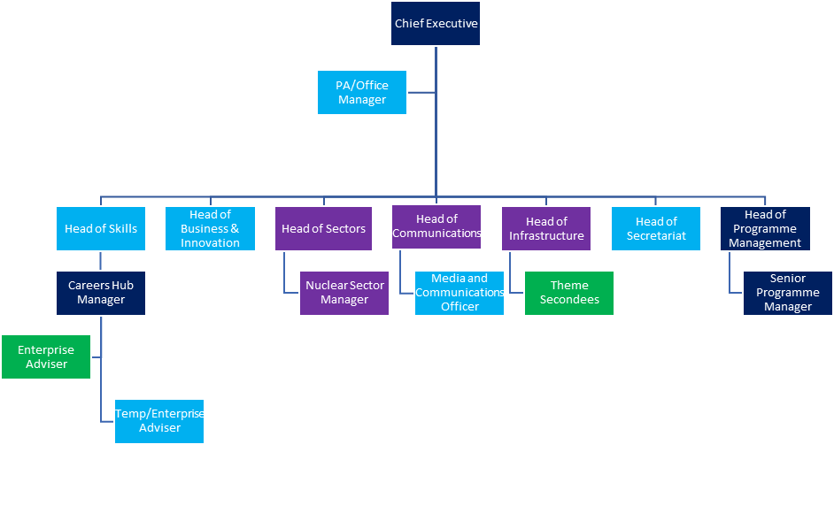

KEY: Dark Blue – CCC Secondees; Purple – Sellafield Secondees; Turquoise CLEP direct employees; Green – Other secondees

Delivery - Key Indicators for the 2019/20
Delivery Plan

The current forecasts are that the activity of the LEP will deliver the following outputs in 2019/20:

Supporting the creation of around 650 new jobs

Levering in around £35 million of investment

Creating and refurbishing 15,935 sqm of premises

Helping the delivery of 145 new homes

Local Growth Fund Activity

CLEP has or plans to support 24 projects via the Local Growth Fund (LGF). Of these projects:

2 are closed and 3 are financially completed but outputs are still being monitored

5 are in development and 1 is in contracting

13 projects are live (although of these only 7 are forecast to be spending in 2019/20).

The overall progress and forecasts of the main outputs recorded for all LGF supported projects is summarised below as is spend.
Table 3.1: LGF Outputs in Cumbria (as of Q4 2018/19)
Output measured | Actual achieved to date* | Forecast for  2019-20 | Current Forecast for  2020-21 | Target (BEIS offer letter) | Total lifetime forecast** | Total approved (lifetime)
Jobs (Created and safeguarded) | 1,816 | 652 | 722 | 4,000 | 6,854 | 5797
New Homes Created | 408 | 145 | 1,468 | 3,000 | 3,400 | 3,400
Leverage (£ms) (Public/Private Sector Leverage/Follow on Investments | £34.38 | £34.89 | £27.45 | £100 | £118.42 | £104.64
Premises Created (Sqm)/Refurbished | 95,061 | 15,935 | 35,956 | 62,000 | 218,769 | 199,905
Serviced Employment Land (Ha) | 2.82 | 9.66 | 3.57 |  | 28.39 | 28.39
Learning Opportunities | 2,169 | 801 | 848 | 1,700 | 7,470 | 4,576
Premises with Access to Superfast broadband | 6,776 | 298 | - | 5,000 | 9,171 | 5,925
Notes: ** including future years beyond 2020-21

Table 3.2: LGF Spend in Cumbria
 | £ms
Total Funding Approved | £60.32
Spend to end 2017/18 | £35.75
Final spend 2018/19 | £6.06
2019/20 | £6.82
2020/21 | £11.69

The momentum on programme delivery continues into Quarter 1 of 19/20, with £3.2m of grant expenditure forecasted to be claimed from Connecting Cumbria, Carlisle Airport, Project Ark and SIS. This equates to 47% of the Offer Letter target for 19/20.

Those projects where spend is expected to be incurred in 2019/20 are:

Kendal Transport Infrastructure improvements, this is being delivered by Cumbria County Council and 2019/20 will see the completion of this £2,300,000 package of works. The transport improvements to roads and cycle infrastructure will support the delivery of a further 115 new homes in 2019/20 (after 408 in 2018/19) and eventually up to 12 hectares of new employment land.

Connecting Cumbria the project to support the roll out of superfast broadband is being delivered by Cumbria County Council. This project is live and of the total £3,600,000 allocation the final element of £1,578,196 is forecast to be spent in 2019/20. Connecting Cumbria has exceeded its output target, ensuring that CLEP has already achieved its Growth Deal target of 5,000 premises with access to superfast broadband. The project is currently forecasting that 9,100 premises will have access to superfast broadband upon its completion.

North Shore in Whitehaven, Copeland is being delivered by Britain's Energy Coast. This project is currently at Outline Business Case stage with a request of £4,473,000. The project should be completed in 2020/21 and is forecast to deliver 28 new jobs, 6,525 sqm of hotel accommodation and £8.1 million in project sector leverage. The project is part of the wider £300 million Whitehaven North Shore development, which will help support diversification of the local economy and the place-making agenda.

Project Ark, James Walker & Co Limited in Cockermouth is live and is expected to be completed in 2019/20, spending £1,837,000 of its allocation of £2,600,000. The project is supporting the development of new flood defences for the business, which was severely affected by flooding in 2015 as a consequence of Storm Desmond. The project has safeguarded 400 high quality jobs and supports a follow-on investment by the business of around £10 million.

M-Sport Evaluation Centre the MEC project comprises the construction of a state of the art R&D facility at the M-Sport Headquarters at Dovenby Hall near Cockermouth. The overall aim of the project is to create a centre of engineering and research excellence that will enable M-Sport to build on their global success as World Rally Champions and expand their motorsport design, development and production operations into wider automotive areas such as small batch partnerships and research and development into electric and battery car technologies. The project will lever £23.4m of public and private sector funding, develop 10,723 sq. metres of business space, and create 101 jobs.

Business Growth Projects two projects to help local businesses expand and access new export markets will be completed in 2019/20. Individual investments in Clark Door and Support In Sport Manufacturing Ltd will support 30 new jobs, safeguard 40 and the £840,000 Growth Deal investment will lead to £3.8 million private sector investment.

Cumbria Coastal Rail will provide £835,000 to support the development of the business case to the Department for Transport (DfT), which if successful will support the ‘Energy Coast’ Rail upgrade. This is a rail infrastructure improvement scheme between Carlisle and Barrow-in-Furness intended to increase rail capacity, improve resilience and ultimately enable a number of major developments to use the rail network for the movement of freight and workforce. The initial project will lever over £8m of investment from DfT and, if successful, has the ability to lever in significant investment to the region.

South Ulverston Infrastructure Improvements involves junction improvements to ensure they operate more effectively and support future development in the town. The schemes will improve access to the A590, minimise delay on the A590, improve pedestrian and cyclist connectivity within South Ulverston. £498,000 of Growth Deal investment will be spent in 19/20. The scheme links closely with the Cumbria Infrastructure Fund (CIF) Cross a Moor project to support the development of housing and employment land opportunities.

In addition to these projects, there are several projects that are completed and have claimed all their LGF but where outputs are expected to be delivered in 2019/20. The principle ones are:

Barrow Waterfront, where £7.,2 million has been invested by LGF. This has funded site reclamation and improvement work to transform derelict land into a business park for employment and advanced manufacturing growth, including site clearance and levelling, decontamination work, removal of industrial debris, provision of utilities, landscaping and raised earthworks for flood protection measures. During 2019/20 the LEP forecasts that there will be around 12,600 sqm of further development.

Barrow Advanced Manufacturing Centre at Barrow College has seen £1.13 million of LGF spend and continues to be an important centre for learning activity.

Durranhill Industrial Estate owned by Carlisle City Council saw £2 million of LGF support for access improvements, site servicing, a new road link and access to release vacant land for development in 2015/16. There continues to be development there with a further 1,500 sqm of new floorspace, 120 new jobs and a further £7 million forecasted for 2019/20.

Skills Capital 1, this £2m programme supported a number of key capital improvements across the further and higher education sector to meet employer demands. The programme included investments at Carlisle College, Kendal College, University of Cumbria, Furness College and Askham Bryan College. To date the programme has delivered 4,756 learning opportunities and is programmed to deliver a further 825 in 2019/20.

Two projects have recently withdrawn from the Growth Deal programme (Atlas Concrete and Lillyhall North). This has created the opportunity for new projects to be incorporated into the programme.

The Board has endorsed the inclusion of an Outline Business Case for the A595 Grizebeck development scheme. This business case responds to the announcement in October 2018 by the Secretary of State on the delivery of improvements to the A595 at Grizebeck, which would be one of the first five schemes to be considered for funding through the Major Roads Network. The proposal seeks to deliver an upgrade to a section of the A595 linking south and west Cumbria.

The cost of this scheme is anticipated to be in the region of £15m and will be confirmed upon submission of an Outline Business Case. A requirement of funding from government is a 15% contribution from local partners. An allocation of £2.25m has been committed to this scheme within the Growth De/al programme, subject to the business case approval process.

CLEP is also working to progress the £1,160,000 Skills Capital 2 programme to ensure that projects can be supported that align with both Local Industrial Strategy and the Skills Investment Plan. In addition, development is accelerating on the Citadels project in Carlisle following the UK and Scottish Government’s support for the Borderlands Inclusive Growth Deal.

Monitoring and Evaluation of the LGF

CLEP completed a major piece of work to introduce revised monitoring and evaluation plans with complete and live projects, to ensure more effective reporting of outputs, outcomes and impacts. This piece of work resulted in a significant improvement in outputs as it identified issues of significant under reporting, particularly of jobs. These new plans place a greater focus on post completion reporting of benefits, including the personnel, methodology and documentation involved in recording of outputs and outcomes. The focus in

CLEP has also reviewed its approach to the utilisation of LGF to consider how this can increasingly be aligned with the Local Industrial Strategy and the priorities within this, recognising that this cannot distract from the delivery of the outputs in the BEIS offer letter. This requires careful consideration as for example job creation is not always immediately reconcilable with productivity improvements. The priority in 2019/20 is to focus remaining investments on those outcomes that are required to deliver those outcomes that have the smallest levels of over-contracting e.g. new homes. However, at this stage in the process the key consideration is deliverability.

A major priority in 2019/20 will be to undertake an economic impact assessment on LGF, which has commenced and will be accelerated once government provides guidance on programme evaluation requirements.

Other Funding or Growth Programmes

ESIF

CLEP relies on reporting from central government in terms of progress of ESIF supported activity in Cumbria. It plays an active role in publicising the programme and its opportunities.

ERDF

Based on current exchange rates Cumbria has an allocation of £49.4 million of ERDF. As of April 2019, across the whole programme £34.34 million of this allocation was contracted or in application stage with a total value of projects of £108m including match funding:

£26.4 million (53%) was contracted

£0.6 million was in a funding agreement in progress and

£7.27 million was in outline or full application stage

leaving £15.09 million (30%) unallocated.

The main issue in Cumbria has been in developing projects in Priority 1 (R&D and Innovation) due to the lack of large scale research-based institutions coupled with the ineligibility of the nuclear sector within the ERDF programme. CLEP has a particularly healthy pipeline of projects in Priority Axis 4 (low carbon) with a number of these now contracted and commencing activity.

Progress and projects of note that are up and running and delivering activity and outputs include:

The £4.1 million Cumbria Innovations Platform programme (CUSP) being delivered by Lancaster University (and also involving the University of Cumbria) aimed at innovation in SMEs (Priority Axis 1).

The ICTIS - Information and Communication Technology Improvement Support project delivered by Allerdale Borough Council (Priority Axis 2).

The Cumbria Growth Hub (see later) and Business Start-up support programmes being delivered by the Chamber of Commerce under Priority Axis 3.

The £2.2 million Eco-Innovation Cumbria programme for SMEs being delivered by the University of Cumbria in Priority Axis 4 which is operational.

The £7.3 million Low Carbon Lake District programme being run by the Lake District National Park Authority, which is now live.

Status of ERDF in Cumbria, February 2019
Status | 1  R&D and Innovation | 2 ICT | 3 Entrepren-eurship | 4  Low Carbon | 5  Climate change adaptation | 6 Resource efficiency | Total
Outline | £0.0 | £0.0 | £0 | £5.39 | £0.0 | £1.37 | £6.77
Full Application | £0.0 | £0.0 | £2.3 | £0.0 | £5.3 | £0.0 | £0.5
Funding agreement in Development | £0.0 | £0.0 | £0.5 | £0.0 | £0.0 | £0.0 | £0.6
Status | 1  R&D and Innovation | 2 ICT | 3 Entrepren-eurship | 4  Low Carbon | 5  Climate change adaptation | 6 Resource efficiency | Total
Contracted | £2.4 | £0.5 | £10.6 | £5.5 | £0.0 | £0.0 | £24.47
Contracted Financial Instruments | £0.0 | £0.0 | £2.0 | £0.0 | £0.0 | £0.0 | £2.0
Total value of projects at all stages | £2.4 | £0.5 | £13. | £10.95 | £5.3 | £1.37 | £34.34
Notional Allocation | £9.19 | £0.6 | £20.9 | £11.43 | £5.7 | £1.5 | £49.4
Balance remaining | £6.74 | £0.1 | £7.27 | £0.48 | £0.4 | £0.14 | £15.1
% taken up | 26.6% | 84% | 65.4% | 95.8% | 94% | 90.4% | 69.5%
% contracted | 26.6% | 84% | 50.7% | 48.5% | 0% | 0% | 53.5%

ESF

Commitment of ESF in Cumbria is performing well with 89% of the total ESF available committed. Where funding remains, for example in measures 1.2 and 1.4, CLEP is working with local partners and DWP to identify possible projects that deliver LIS objectives and maximise spend.

Cumbria
IP | Allocation (€) | Allocation (£) | ESF Committed Spend | Pipeline  (including Project change requests and appraisals)
1.1 | €10,879,168 | £ 9,464,876 | £ 9,483,333 | £1,103,697 DWP
1.2 | € 2,328,076 | £ 2,025,426 | £ 1,200,000
1.4 | € 3,826,631 | £ 3,329,169 | £ 2,500,000 | £ 539,116 BLF
2.1 | €18,655,332 | £16,230,138 | £16,424,750
2.2 | € 2,628,137 | £ 2,286,479 | £ 0 | £2,284,459 Direct
Total | €38,317,344 | £33,336,089 | £29,608,083 | £3,927,272

There has been generally good progress in commitment of delivery of the number of participants compared to targets, as outlined overleaf. CLEP’s focus over 2019/20 is working with partners to ensure that projects are successfully delivered and both spend and beneficiary outputs achieved.
Participants | 2023 target | Total committed to date | Total committed as % of target
1.1 Access To Employment For Job-Seekers And Inactive People | 9,062 | 8,398 | 93%
1.2 Sustainable Integration Of Young People | 2,098 | 1,124 | 54%
1.4 Active Inclusion | 1,771 | 976 | 55%
PA1 Total | 12,931 | 10,498 | 81%
2.1 Enhancing Equal Access To Lifelong Learning | 13,886 | 11,998 | 85%
2.1 Improving The Labour Market Relevance Of Education And Training Systems | 238 | 0 | 0%
PA 2 Total | 14,124 | 11,998 | 85%
Total | 27,055 | 22,496 | 83%

EAFRD
Element | Businesses development | Food processing | Tourism | Total
Funding Available | £2.83 | £1.75 | £3.17 | £7.75
Current pipeline spend | £2.42 | £0.78 | £5.58 | £8.79
Under or over programmed | -£0.4 | -£0.97 | +£2.41 | +£1.04
Contracted | £1.02 | £0.74 | £1.65 | £3.24
Number of projects contracted | 9 | 5 | 10 | 24

Growing Places Fund/ Cumbria Infrastructure Fund

The Cumbria Infrastructure Fund is the local implementation of the Growing Places Fund. The fund was established to promote the delivery of key infrastructure needed to unlock developments that help generate jobs and homes. The total amount of funding awarded was £6.1 million and was established to act as a revolving fund to allow future investments to be made once returns to the programme are made. Funds have already started to be reinvested as the programme has committed a total of £8.7m to projects.

Progress and activity is as follows:

Over 200 new homes being developed across four housing sites in South and West Cumbria.

53 jobs created through the Small Business Development Loan scheme. This is an investment programme within CIF established to support SMEs access to finance for small scale capital developments. There are three remaining live projects within the programme tasked with creating 61 jobs.

In 19/20 the programme will see the completion of the contracting of the Cross a Moor scheme which will see the development of a roundabout in South Ulverston. Through this, four housing sites will be “opened up” and, working with housing developers, over 1,000 new homes will be created over future years. Repayments will be made to the fund through Section 106 agreements agreed between the Planning Authority and Developers.

Enterprise Zone

CLEP secured Enterprise Zone status for Kingmoor Park in Carlisle. The EZ became operational on 1 April 2016 for a 25-year period, offering a combination of business rates relief and capital allowances. The EZ site is 122 hectares in total of which 49 hectares are already developed.

Kingmoor Park is located just off Junction 44 of the M6, and has the potential to create an additional 3,000 jobs in advanced manufacturing, nuclear supply chain and logistics. It is highly accessible and offers considerable opportunity to attract new investors to the County and offer grow-on space for existing businesses. Specific progress and activity is as follows:

In 2018/19 new speculative development comprising 19 units and 55,000 sq. ft of commercial floor space was completed. Marketing of these units is now underway during 2019/20 and initial interest is strong from SMEs and growing ventures.

Proposals are being finalised for a solar farm development to provide a green energy solution to the site’s private power supply (offering 12-15% of the business park’s current energy requirement)

A Waste from Energy power plant section 73 application by Verus Energy was successful in January 2019 and the project is being progressed in 2019/20.

A revised commercial masterplan for the EZ site will be completed in 2019/20

During 2018/19 Zone G access road was complete to the phase 1 standard to provide access to new plots

Total employment levels in the EZ have now reached 2,500 jobs.

The priority in 2019/20 will be exploring with government the baseline for the EZ, which was very high and the focus following the demise of NuGEN and its proposal for a major new nuclear development at Moorside.

Cumbria Growth Catalyst

The Cumbria Growth Catalyst programme is being delivered by the Cumbria Chamber of Commerce and is aimed at ensuring that there is a single point of contact for businesses seeking support to grow in the county. The programme complements that provided through ERDF funding through ensuring those sectors and businesses that are ERDF-ineligible can access appropriate support.

Cumbria County Council received the annual offer letter for funding of £246,000 on 23 April 2019 from BEIS, following approval of the delivery schedules jointly submitted by CLEP and the Council. The original contract with Cumbria Chamber of Commerce will therefore be extended for 2019/20 and with revised performance targets of:

Triage (telephone service) - 532 hours (minimum)

Diagnostics - 779 @ 3 hours

Scale up Assists - 88 @ 12 hours (for businesses with the ambition and potential to increase turnover by 50% within three years

Workshops - 32 (spread across 6 districts)

A new Evolutive CRM system has been introduced to provide CLEP with real time access to data and to support the monitoring of contractor performance, sectoral and geographical distribution of support and to facilitate reporting to BEIS.

Amion has been appointed to undertake an independent interim review of the programme, bearing in mind the delayed start to the programme. It will subsequently complete a whole programme evaluation looking at how the whole programme can be improved. Additionally, a satisfaction survey will be conducted by the Chamber of Commerce.

Northern Cultural Regeneration Fund (NCRF)

Cumbria has been awarded £3.2 million in funding from the NCRF which is supported by DCMS. This funding is supporting the World Heritage Lake District Programme which comprises three complementary projects:

Windermere Jetty Museum of Boats, Steam and Stories. This has been allocated £2.3m in NCRF support which has helped contribute to the overall £20 million cost of the project. The new museum at Windermere Jetty replaces the former Windermere Steamboat Museum and opened to the public on 23rd March 2019. To date it has received £1.14m of the £2.3m grant approval. The project will support 29 FTE jobs and is expected to receive around 120,000 visits per year.

The Reimagining Wordsworth project will transform the Wordsworth Museum in Grasmere, which holds the finest collection of Wordsworth’s manuscripts anywhere in the world. The contract will be in place in May 2019 and will receive £495,000 in NCRF support. The project will be substantially completed during 2019/20. It will support creation of 5 FTEs and 16,500 additional visitors.

Abbot Hall is home to a significant visual arts collection in Kendal. The project will enable the museum will undergo vital refurbishment across its Main Galleries; create a new Project Space for exhibitions and artist residencies, community projects and workshops; and achieve full accessibility across the buildings and site. The project is expected to commence in 2019/20 and be completed in 2020/21.

Career Hub/Enterprise Advisors

The Enterprise Adviser Network (EAN) was launched in Cumbria in 2016. It is a programme that focuses on developing a national network that connects schools and colleges with employers and careers programme providers and supports them to work together to provide young people with effective and high-quality encounters with the world of work. This work was undertaken in partnership the Careers and Enterprise Company.

In July 2018 building on this work, CLEP with the backing of local education and skills partners, employers and stakeholders was successful in its bid to take part in a national pilot to establish a Careers Hub. The purpose of the Career Hub is to transform careers education for young people through:

Continued building of networks across schools, colleges to employers and other external careers advisers

Supporting careers leaders – by providing training and support

Supporting schools and colleges to achieve the eight Gatsby benchmarks- Indicators of good quality careers advice by supporting and developing excellence and innovation in practice.

During 2018/19 we made considerable progress. The Hub lead was recruited and 40 schools and colleges were engaged with the Hub – The target is to ensure all schools and colleges are matched to an enterprise adviser by July 2019. The Careers Hub programme at this stage is set to run until August 2020. The national commitment to the Enterprise Adviser Network is set to continue beyond this date.

Targets for 2018/2019 (Academic) are:

80% of all Hub institutions fully achieve the Gatsby Benchmark 5 (for encounters with employers and employees)

50% reduction of Hub institutions scoring in the 0-25% achievement category for this benchmark

50% of all Hub Institutions to have achieved Gatsby Benchmark 6 (Experiences of the workplace)

A further 35% of Hub institutions partially achieve benchmark 6

An average of 4 Gatsby Benchmarks by all Careers Hub schools and colleges.

Targets for 2019/2020 (Academic) are:

90% of all Hub institutions fully achieve the Gatsby Benchmark 5 (for encounters with employers and employees)

No Hub schools/colleges scoring in the 0-25% category for benchmark 5

60% of all Hub Institutions to have achieved Gatsby Benchmark 6(Experiences of the workplace) A further 35% of Hub institutions partially achieve benchmark 6

An average of 6 Gatsby Benchmarks by all Careers Hub schools and colleges and full achievement of all 8 benchmarks by lead schools / college.

International Trade (DIT)

During 2018/19 CLEP re-commenced NPH Key Account Management (KAM) during Quarter 4, after a period of non-engagement. The focus of Quarter 4 activity was therefore in establishing:

a baseline position of internationally owned businesses,

a refreshed DIT datahub with up to date information and

identification of at least 18 locally managed companies (plus an additional 5 One List KAM portfolio companies) which show growth potential through appropriate contact, visits and the associated reports (in line with the DIT Account Management Framework

Proposed activity in 2019/20 is therefore focused on taking this work programme into implementation phase. In addition, there is the potential for an additional 8 One lists Companies, plus a number of new entrants around the recently announced Frameworks at Sellafield CLEP Strategic Activity.

Multi-LEP and working outside Cumbria

CLEP is involved in several partnerships and range of activities outside our boundaries:

CLEP is a member of the Northern Powerhouse 11 (NP11) and has committed to work collaboratively with the other 10 LEPs within the NP11 on the work programme that is being developed. We are currently taking a lead on the Places work for NP11.

The cross-LEP working on the nuclear sector with the other North West LEPs, Heart of the South West and New Anglia LEPs.

CLEP is committed to and actively engaging in the Borderland Inclusive Growth Deal. This is a cross-Border initiative consisting of Carlisle City Council, Cumbria County Council, Dumfries and Galloway Council, Northumberland Council and Scottish Borders Council that received a substantial funding allocation in the March 2019 Budget Statement.

We work collaboratively with other adjoining LEPs on a project or strategic basis (e.g. with Lancashire LEP on the Morecambe Bay Economic Area proposal).

Partnership working within Cumbria

During 2018/19, as outlined previously, CLEP had a particularly intensive programme of partnership working associated with the development of our LIS and new governance structures.

Engaging with the business community

The business sector engagement takes place through several channels:

Our formal governance structures have a very strong business representation. We have 9 Sector Panels covering the rural economy (largely responsible for agri-food), the visitor economy, the creative & cultural sector, nuclear, advanced manufacturing, construction, logistics, professional services and health & social care. At least 150 businesses are members of these Sector Panels, which meet every 2 to 3 months. Businesses are also represented on the LEP other key governance sub-committees (five Strategy Groups covering the five foundations of productivity).

The LEP holds an Annual General Meeting in September. The 2018 AGM was attended by over 70 organisations including many businesses.

In addition, LEP staff attend, present and answer questions at a wide range of business dinners, business networking events and business clubs on an ad hoc basis. During 2019/20 CLEP intends to set up a new Cumbria Business Leadership Team (modelled on bur complementary to the North West BLT) for our largest businesses.

Engaging with wider public, voluntary and community-based bodies

The wider public, voluntary and community-based bodies also are represented in our governance structure and sit on different sector panels and Strategy Groups. In addition the LEP engages with the public sector via:

The Cumbria Chief Executives Group

The Technical Officers Groups (of local economic development leads for our 7 local authorities, the Lake District National Park and other bodies such as Natural England)

Moorside Strategic Partnership

As with the business sector, LEP staff attend, present and answer questions at a wide range of networking events and conferences on an ad hoc basis. These include the Cumbria CVS. There is also a VCSE nomination on the CLEP Board and throughout the wider governance structure.

Other soft power/convenor roles

The LEP regards the LIS as its main vehicle for influencing partners in Cumbria. The LIS is already starting to have considerable traction around its key themes (for instance the identification and highlighting of the looming workforce deficit is influencing the updating of the Local Plan in Eden).

The work in preparing the LIS and its evidence base during 2018/19 has led to CLEP working with partners in Cumbria on a range of activities including:

Developing a new place marketing and promotion propositions for Cumbria

Completing a formal mapping of sites and premises needs across Cumbria

Encouraging businesses to identify practical activity they can take supporting their CSR agendas that help deliver inclusive growth

Commissioning a new Creative and Cultural Strategy.

Developing Cumbria’s contribution to the Tourism Sector Deal and developing a proposal for Tourism Action Zone status.

Developing a visitor economy response to the Lake District Local Plan.

Glossary of Terms

Term | Description
Accountable Body | The arrangement whereby Cumbria County Council has agreement to accept responsibility for the obligations set out in the terms of any funding granted to Cumbria Local Enterprise Partnership.
BEIS | Department for Business, Energy and Industrial Strategy – Government department. Formed in 2016, BEIS replaced the Department for Business, Innovation and Skills (BIS) and the Department of Energy and Climate Change (DECC).
Borderlands Inclusive Growth Deal | Cross Border initiative consisting of Carlisle City Council, Cumbria County Council, Dumfries and Galloway council, Northumberland Council and Scottish Borders Council that received a funding allocation in the March 2019 Budget Statement, creating a package of around £345m in total.
Careers Hub | A group of between 20 and 40 secondary schools and college located in the same geographic area, working together and with partners in the business, public, education and voluntary sectors to deliver the Gatsby Benchmarks, ensuring careers outcomes are improved.
CSR | Corporate Social Responsibility
Cumbria CVS | Cumbria Council for Voluntary Service
Cumbria Growth Catalyst | Programme being delivered by the Cumbria Chamber of Commerce aimed at ensuring there is a single point of contact for businesses seeking support to grow in the County.
Cumbria Infrastructure Fund (CIF) | The local implementation of the Growing Places Fund established to promote the delivery of key infrastructure needed to unlock developments that help generate jobs and homes. £6.1 million of funding was awarded and was established to act as a revolving fund.
DIT | Department for International Trade – Government Department.
DWP | The Department for Work and Pension – Government Department.
EAFRD | The European Agricultural Fund for Rural Development.
Economic Impact Assessment | A specific form of analysis technique which calculate the direct, indirect and induced benefits from projects in order to measure likely outputs and outcomes.
Enterprise Advisor Network (EAN) | Programme focused on developing a national network connecting schools and colleges with employers and careers programme providers, supporting them to work together to provide young people with effective and high-quality encounters with the world of work.
Enterprise Zone (EZ) | Designated areas across England that provide tax breaks and Government support to enable local economic growth as part of the Government’s wider Industrial Strategy.
ERDF | The European Regional Development Fund. Aimed at strengthening economic and social cohesion in the European Union by correcting imbalances between its regions, investments are focussed on several key priorities.
ESF | The European Social Fund. Aimed at supporting jobs, helping people get better jobs and ensuring fairer job opportunities for all EU citizens.
European Structural Investment Funds (ESIF) | Term referring to 5 European structural and investment funds jointly managed by the European Commission and the EU countries. The 5 funds are: European regional development fund, European social fund, Cohesion fund, European agricultural fund for rural development, European maritime and fisheries fund.
Gatsby Benchmarks | A framework of 8 guidelines that define the best careers provision in schools and colleges.
Growing Places Fund | A national fund to support key infrastructure projects designed to unlock wider economic growth, create jobs and build houses in England, which is distributed in Cumbria as the Cumbria Infrastructure Fund.
Growth Deal | Provision of funds to local enterprise partnerships for projects that benefit the local area and economy.
LEP Network | A not-for-profit company limited by guarantee, governed by three volunteer LEP chairs, that aims to be a gateway to news and information that enables LEPs to come together on areas of shared importance, engage with government, facilitate dialogue with economic development stakeholders, and share knowledge and best practice.
Local Assurance Framework | Document supporting the development and delivery of a rigorously appraised and prioritised investment programme for Cumbria, ensuring that CLEP has in place the necessary systems and processes to manage delegated funding from central Government budgets effectively and fully in line with government’s expectation as outlined in the National Local Growth Assurance Framework (January 2019). The Framework outlines the policies, processes and procedures that Cumbria LEP will follow in relation to decision making within its Growth Programme.
Local Enterprise Partnership (LEP) | Local business led partnerships between local authorities and businesses. Set up in 2011 by the Department for Business, Innovation and Skills in order to play a central role in determining local economic priorities and undertaking activities to drive economic growth and the creation of local jobs.
Local Growth Fund | A capital programme consisting of the local allocation of Growth Deal monies, which in Cumbria represents the £60.2m of funding agreement with Government between 2014 and 2017.
Local Industrial Strategy (LIS) | Strategic document, led by Mayoral Combined Authorities or Local Enterprise Partnerships, to promote the coordination of local economic policy and national funding streams and establish new ways of working between national and local government, and the public and private sectors aligned to the national modern Industrial Strategy.
Major Roads Network | A proposed classification of local authority roads in England incorporating the existing Highways England controlled Strategic Road Network and the more major local authority controlled A roads.
Mary Ney Review | A review of LEP governance and transparency conducted by Mary Ney, a Ministry of Housing, Communities and Local Government (MHCLG) non-executive director following a report by the Public Affairs Committee in July 2016. The aim of the review was to provide sufficient assurance to the Accounting officer and ministers that LEPs fully implement existing requirements for appropriate governance and transparency.
Morecambe Bay Economic Area | A cross-county area around Morecambe Bay, encompassing Cumbria and Lancaster.
Natural Capital | The assets of the local environment which provide valuable goods and services to people.
Northern Cultural Regeneration Fund (NCRF) | A £15 million fund with grants of up to £4 million available to support major culture and tech capital projects in Northern England.
Northern Powerhouse (NPH) | A mechanism to bring together the cities, towns and rural communities of the North to boost economic growth through modern transport links, aligned governance and increased investment.
Northern Powerhouse 11 (NP11) | The 11 Local Enterprise Partnership Areas of the North of England which define the spatial footprint of the Northern Powerhouse.
Outcomes | The eventual benefits to society that proposals are intended to achieve.
Outputs | The results of activities that can be clearly stated or measured and which relate in some way to the outcomes desired from the activity.
Skills Capital | A programme of investment in skills capital projects following Government transferring the skills capital budget previously managed by the Skills Funding Agency to LEPs via the Local Growth Fund.
SME | Small and Medium Enterprises, usually defined as any business with fewer than 250 employees.
Strategic Economic Plan (SEP) (Cumbria) | Strategic document published in 2014 setting out a 10 year plan for how Cumbria’s economy can deliver jobs, business growth, improved skills, new infrastructure, housing and a range of other economic benefits.
Strengthened Local Enterprise Partnerships | Policy document setting out the role and responsibilities of Local Enterprise Partnerships in driving local growth. It sets out how government and Local Enterprise Partnerships will work together to strengthen leadership and capability, improve accountability and manage risk, and provide clarity on geography.
Tourism Action Zone status | Recognition of a tourism zone within the Tourism Sector Deal to build quality tourism products that meet visitor needs and expectations, extending the tourism season and fixing localised transport issues.
VCSE | Voluntary, Community and Social Enterprise

